Unemployment Free Response Questions
- The table below shows unemployment and labor force statistics for an economy.
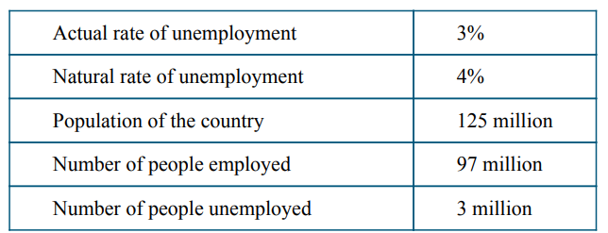
6 million
350 million
144 million
3%
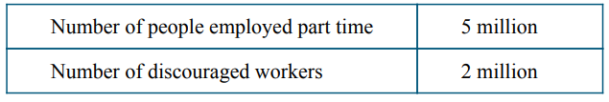
3 million
(a) Calculate the size of the labor force. Show your work.
(b) Calculate the labor force participation rate. Show your work.
(c) Given the state of the economy described in the table, is actual real output less than, greater than, or equal to potential real output? Explain.
(d) Calculate what the cyclical unemployment rate would be if the actual rate of unemployment increased to 3.5 percent. Show your work.
(e) Calculate what the cyclical unemployment rate would be if the actual rate of unemployment decreased to 2.7 percent. Show your work.
(f) Suppose some discouraged workers reenter the labor force and but do not find employment. Will the actual rate of unemployment increase, decrease, or stay the same?
2. The table below shows unemployment and labor force statistics for an economy.
- A) LF = 144 + 6 = 150 million
b) LFPR = LF / working age pop = 150 / 350 (use pop if there is no working age population)
= 42.9%
c) ARU < NRU, therefore Actual Output > Potential Output
d) ARU = NRU + cyclical, therefore cyclical = ARU – NRU = 3.5 – 4 = -0.5%
e) cyclical = 2.7 – 4 = -1.3%
f) UR = UR / LF = 6 / 150 -> UR = >6 / >150
because the numerator will increase by a larger percentage, the UR will increase! (shows the flaw of the UR rate, because people trying to look for jobs again is a good thing even though the UR becomes worse)

100 million
6%
(a) Calculate the size of the labor force. Show your work.
(b) Calculate the labor force participation rate. Show your work.
(c) Given the state of the economy described in the table, is actual real output less than, greater than, or equal to potential real output? Explain.
(d) Calculate what the cyclical unemployment rate would be if the actual rate of unemployment increased to 7 percent. Show your work.
(e) Calculate what the cyclical unemployment rate would be if the actual rate of unemployment decreased to 3 percent. Show your work.
(f) Suppose some discouraged workers reenter the labor force and DO find employment. Will the actual rate of unemployment increase, decrease, or stay the same?

- A) LF = 100 + 3 = 103 million
b) LFPR = LF / working age pop = 103 / 125 (use pop if there is no working age population)
= 82.4%
c) ARU > NRU, therefore Actual Output < Potential Output
d) ARU = NRU + cyclical, therefore cyclical = ARU – NRU = 7 – 4 = 3%
e) cyclical = 3 – 4 = -1%
f) UR = UR / LF = 3 / 103 -> UR = 3 / >150, decrease UR
numerator will stay the same, the LF will increase, therefore UR decrease

